Dr. Surendra Kumar
Production Function
The functional relationship between physical inputs (or factors of production) and output is called production function. It assumed inputs as the explanatory or independent variable and output as the dependent variable. Mathematically, we may write this as follows:
Q = f (L,K)
Here, ‘Q’ represents the output, whereas ‘L’ and ‘K’ are the inputs, representing labour and capital (such as machinery) respectively. Note that there may be many other factors as well but we have assumed two-factor inputs here.

Time Period and Production Functions
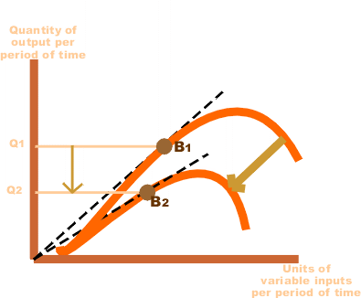
The production function is differently defined in the short run and in the long run. This distinction is extremely relevant in microeconomics. The distinction is based on the nature of factor inputs.
Those inputs that vary directly with the output are called variable factors. These are the factors that can be changed. Variable factors exist in both, the short run and the long run. Examples of variable factors include daily-wage labour, raw materials, etc.
On the other hand, those factors that cannot be varied or changed as the output changes are called fixed factors. These factors are normally characteristic of the short run or short period of time only. Fixed factors do not exist in the long run.
Consequently, we can define two production functions: short-run and long-run. The short-run production function defines the relationship between one variable factor (keeping all other factors fixed) and the output. The law of returns to a factor explains such a production function.
For example, consider that a firm has 20 units of labour and 6 acres of land and it initially uses one unit of labour only (variable factor) on its land (fixed factor). So, the land-labour ratio is 6:1. Now, if the firm chooses to employ 2 units of labour, then the land-labour ratio becomes 3:1 (6:2).
The long-run production function is different in concept from the short run production function. Here, all factors are varied in the same proportion. The law that is used to explain this is called the law of returns to scale. It measures by how much proportion the output changes when inputs are changed proportionately.
The main theme of production function is to get the maximum production with the present given set of variable.
Eg: a firm can use the more labour and less machines OR it can use less labour and more machines to get maximum production. Here which is suited best and how to find the best alternative choice is the main aim of production function.
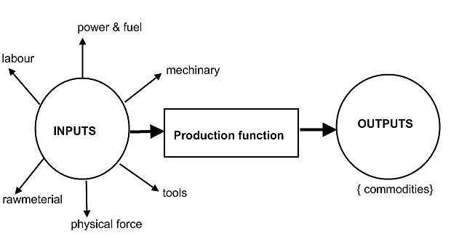

In a general mathematical form, a production function can be expressed as:

- Q=output/quantity
- LB = Land & Buildings.
- L = Labour.
- K = capital.
- M = raw material.
- t= time.

